**2) Alarm Clock**

If light sensor senses light, then sound of choice is played. If there is no light, then the sound stops. Light + Light Sensor = Very Loud Sound

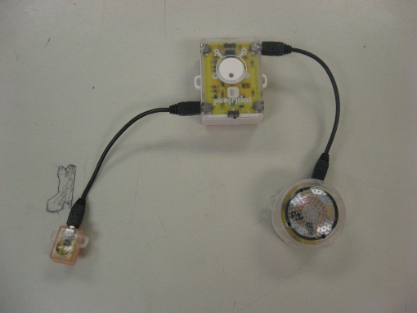

**1) Windmill**

When resistance is grater then a number then the motor board sends a signal to the motor to spin around at a curtain speed**.**

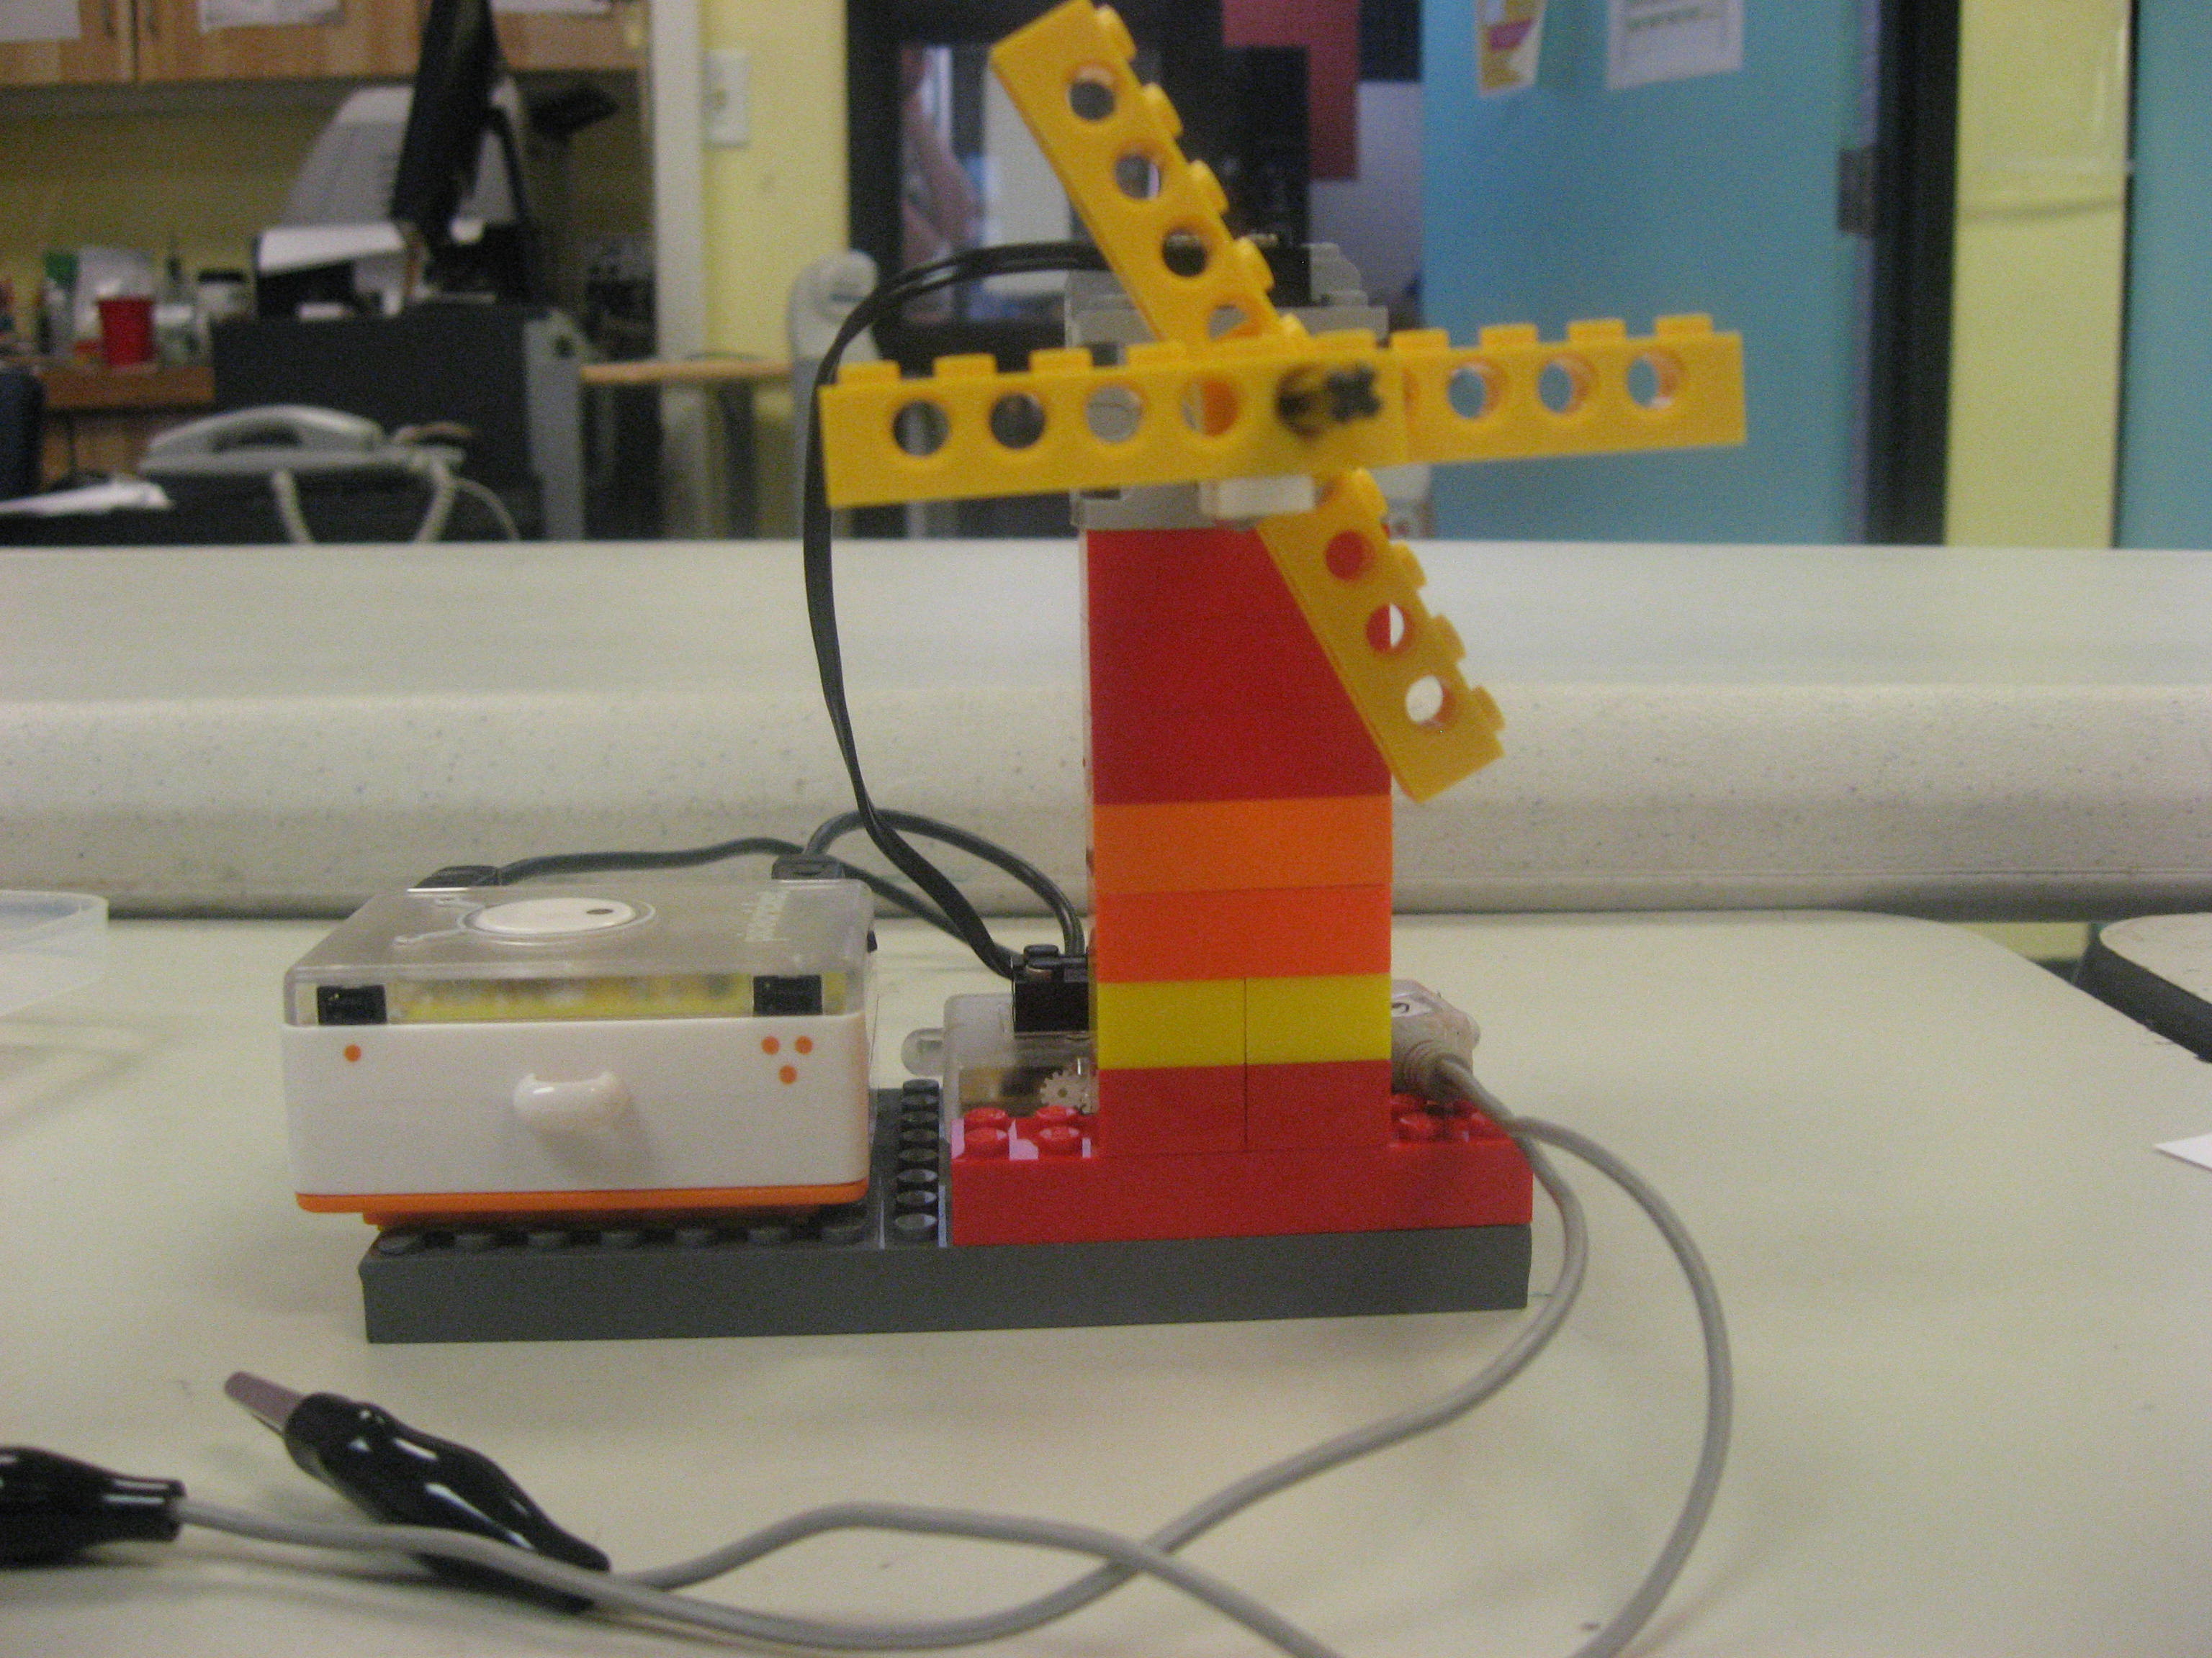

**4)** **Reaction Game**

Wait 5-10 seconds and lights will turn on, then press touch sensor. Your time will then show on display board then reset.

The time it took you to press the touch sensor will be the time on the display board



**3) Red light Green light**

When the sound sensor picks up sound the colored lights will turn red or green. You can even make it so that the lights are a different color!

