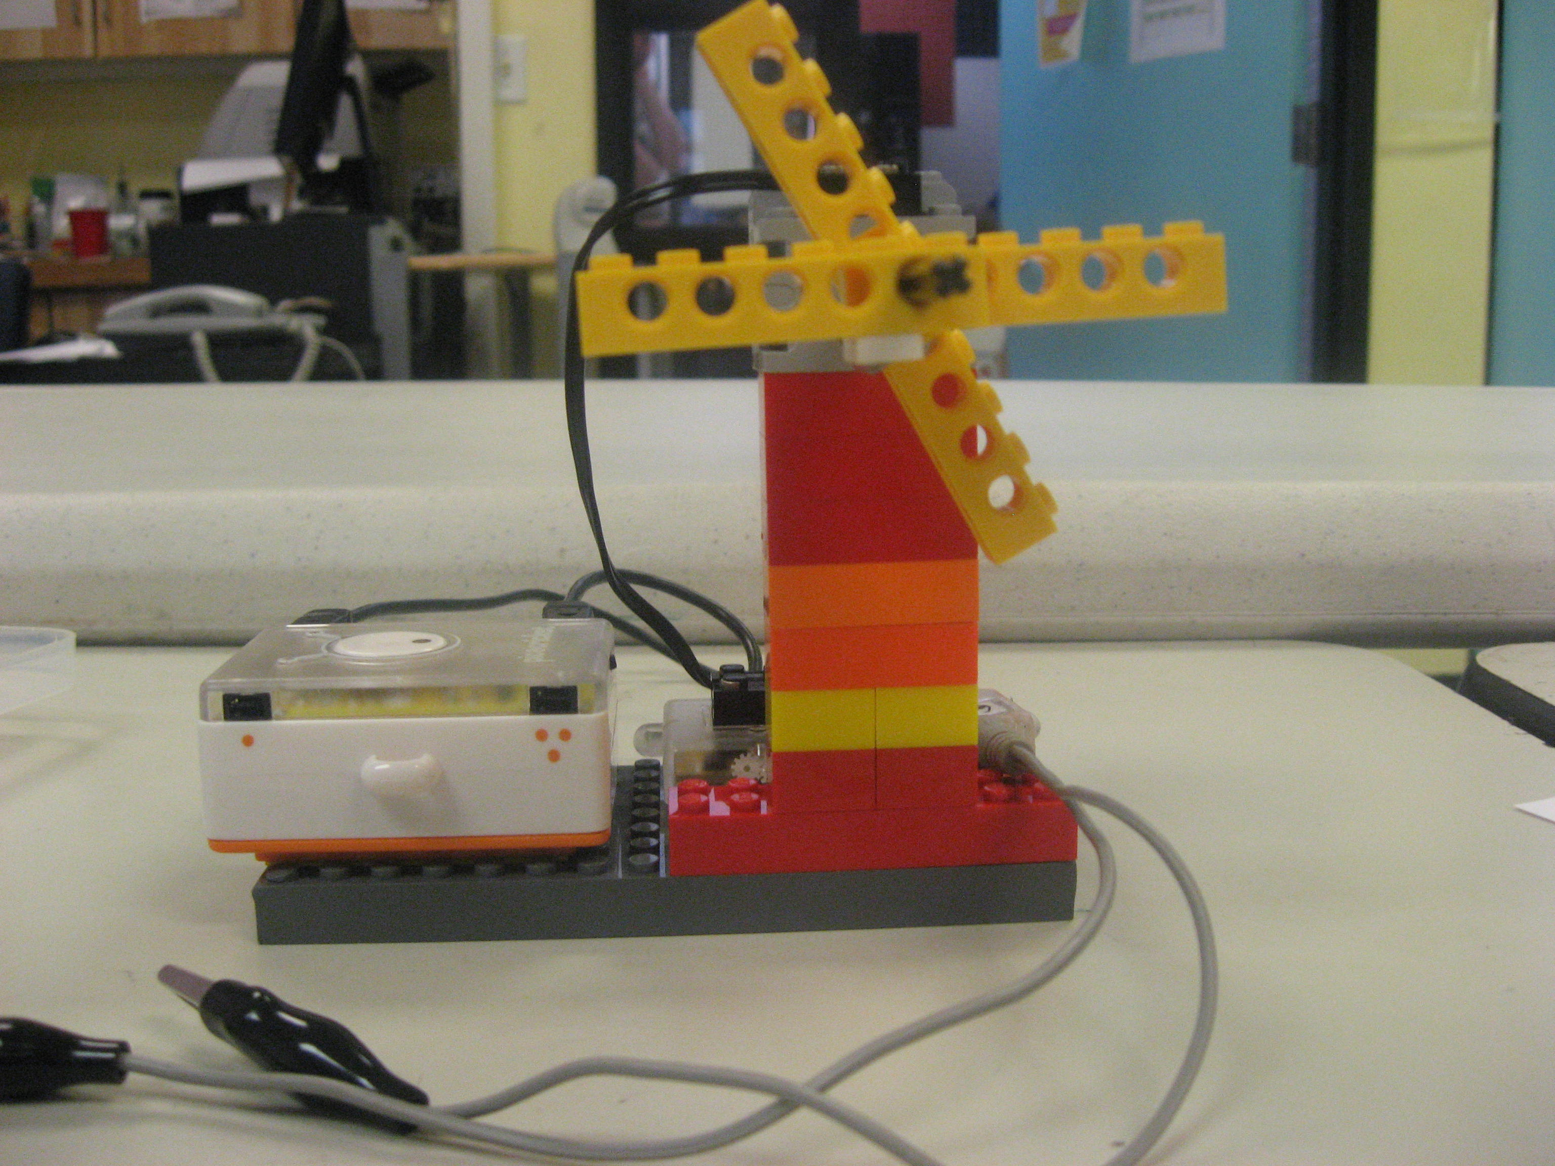  I made a Windmill  I am a  Physical  Programmer  Learn 2 Teach; Teach 2 Learn |  | I made a Windmill  I am a  Physical  Programmer  Learn 2 Teach; Teach 2 Learn |  | I made a Windmill  I am a  Physical  Programmer  Learn 2 Teach; Teach 2 Learn
I made a Windmill  I am a  Physical  Programmer  Learn 2 Teach; Teach 2 Learn |  | I made a Windmill  I am a  Physical  Programmer  Learn 2 Teach; Teach 2 Learn |  | I made a Windmill  I am a  Physical  Programmer  Learn 2 Teach; Teach 2 Learn
I made a Windmill  I am a  Physical  Programmer  Learn 2 Teach; Teach 2 Learn |  | I made a Windmill  I am a  Physical  Programmer  Learn 2 Teach; Teach 2 Learn |  | I made a Windmill  I am a  Physical  Programmer  Learn 2 Teach; Teach 2 Learn
I made a Windmill  I am a  Physical  Programmer  Learn 2 Teach; Teach 2 Learn |  | I made a Windmill  I am a  Physical  Programmer  Learn 2 Teach; Teach 2 Learn |  | I made a Windmill  I am a  Physical  Programmer  Learn 2 Teach; Teach 2 Learn
I made a Windmill  I am a  Physical  Programmer  Learn 2 Teach; Teach 2 Learn |  | I made a Windmill  I am a  Physical  Programmer  Learn 2 Teach; Teach 2 Learn |  | I made a Windmill  I am a  Physical  Programmer  Learn 2 Teach; Teach 2 Learn
I made a Windmill  I am a  Physical  Programmer  Learn 2 Teach; Teach 2 Learn |  | I made a Windmill  I am a  Physical  Programmer  Learn 2 Teach; Teach 2 Learn |  | I made a Windmill  I am a  Physical  Programmer  Learn 2 Teach; Teach 2 Learn
I made a Windmill  I am a  Physical  Programmer  Learn 2 Teach; Teach 2 Learn |  | I made a Windmill  I am a  Physical  Programmer  Learn 2 Teach; Teach 2 Learn |  | I made a Windmill  I am a  Physical  Programmer  Learn 2 Teach; Teach 2 Learn
I made a Windmill  I am a  Physical  Programmer  Learn 2 Teach; Teach 2 Learn |  | I made a Windmill  I am a  Physical  Programmer  Learn 2 Teach; Teach 2 Learn |  | I made a Windmill  I am a  Physical  Programmer  Learn 2 Teach; Teach 2 Learn
I made a Windmill  I am a  Physical  Programmer  Learn 2 Teach; Teach 2 Learn |  | I made a Windmill  I am a  Physical  Programmer  Learn 2 Teach; Teach 2 Learn |  | I made a Windmill  I am a  Physical  Programmer  Learn 2 Teach; Teach 2 Learn
I made a Windmill  I am a  Physical  Programmer  Learn 2 Teach; Teach 2 Learn |  | I made a Windmill  I am a  Physical  Programmer  Learn 2 Teach; Teach 2 Learn |  | I made a Windmill  I am a  Physical  Programmer  Learn 2 Teach; Teach 2 Learn

