WHAT WILL YOUR AVATAR SAY?!

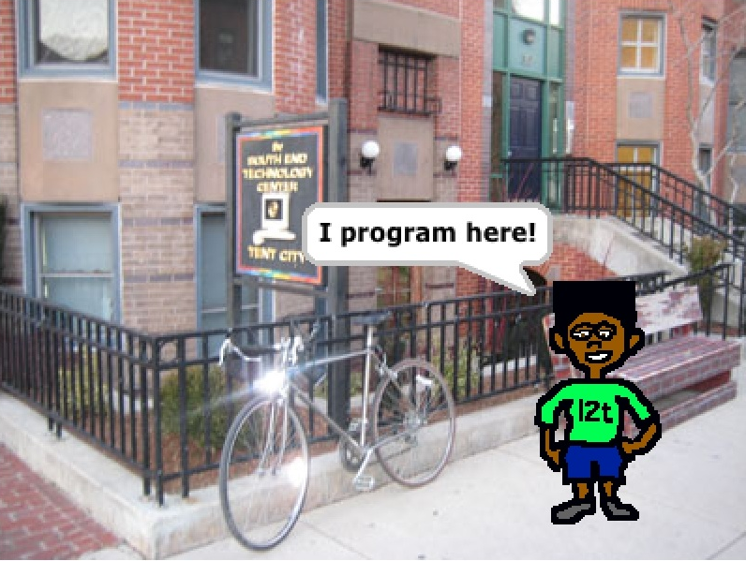

**CREATE A SPRITE OF YOURSELF &**

**PUT IT IN THE PERFECT STAGE …**

This activity teaches

**computer programming**

through animation and Scratch!

**av·a·tar :** a graphical image that represents a person